Practicum No.7 Date:……….
Cache Mapping Technique Analysis

- Practical Significance

Cache memory plays a critical role in speeding up data access in computers. Different cache mapping techniques like direct, associative, and set-associative affect how data is stored and retrieved. By analyzing these methods with the given mapping approach, students can understand the trade-offs between speed and efficiency. This practicum helps students appreciate how smart memory use can improve system performance.

- Competency and Industry-Specific Practical Skills

This practicum exercise is expected to develop the following skills for the industry-identified competency.
- Evaluate the performance of scalable architectures for intelligent systems to ensure reliability.
(As stated in the Course Structure)
- Implement cache mapping techniques and simulate direct memory access operations. (PDO)

- Relevant CO(s) (As stated in the Course Structure)

- CO3. Interpret memory functions and techniques influencing performance.

- Practical Outcome (PrO) (As stated in the Course Structure)

- Simulate cache behavior with the given mapping method using MATLAB

- Related ADO(s) (As stated in the Course Structure)

- Follow industry standards for system evaluation and performance optimization.
- Function effectively in teams to develop processor and memory architectures.
- Function responsibly in leadership roles to design computing systems.

- Minimum Underpinning Theory (Include relevant content & images for this practicum.)

Cache memory is a small, high-speed memory located close to the CPU, used to reduce access time to frequently used data. Since cache size is limited, mapping techniques determine how data from main memory is placed in the cache. The three common techniques are Direct Mapping (one memory block maps to one cache line), Associative Mapping (any memory block can go to any cache line), and Set-Associative Mapping (a hybrid that groups cache lines into sets).
These techniques influence the hit rate and efficiency of the cache. Direct mapping is simple and fast but prone to collisions, while associative mapping is more flexible but slower due to search overhead. Set-associative mapping offers a balance between speed and flexibility. Analyzing these with tools helps students understand how cache design impacts performance and guides the development of faster computing systems.
- Algorithm (Include probable photos of experimental set-up.)

Steps to Analyze Cache Behavior (Direct Mapping)
Step 1: Define Cache and Initialize
Choose a small cache size (e.g., 4 slots).
Create an array to represent the cache and set all values to empty (e.g., -1).

Step 2: Prepare Memory Access Sequence
Create a list of memory block numbers that simulate how a CPU accesses memory.
Example: [0, 4, 1, 5, 0, 4, 2, 6, 3]

Step 3: Apply Direct Mapping Formula
Use the formula:
cache_index = block_number mod cache_size
This tells you where in the cache the block should go.

Step 4: Check for Cache Hit or Miss
If the block is already at the calculated cache index → Hit
If not → Miss, and replace the block at that index.

Step 5: Display Result
For each memory access, display:

The block number
The cache index
Whether it was a hit or a miss
The current state of the cache

Step 6: Repeat for All Memory Accesses
Loop through all the blocks in the sequence.
Count the number of hits and misses to understand cache performance.

- Resources Required

S. No. | Resource | Suggested Broad Specification | Quantity
1 | Laptop | Intel Core i5/i7 processor, 8GB RAM, Windows OS recommended for 8086 emulator | 1 No.
2 | MATLAB | https://matlab.mathworks.com/ | 1 No.

- Safety Precautions

- Do not run unfamiliar or unverified scripts found online which may harm your computer.
- Verify your register usage and memory addresses to avoid system-level crashes or infinite loops.
- Close all other programs before executing large or unknown assembly code to free up resources.
- Use licensed version of MATLAB to avoid security or legal issues.

- Procedure (Self-Instructional)

1. Switch on the computer.
2. Open MATLAB on your computer.
3. Create a new script file (File → New → Script).
4. Run the following MATLAB script and note the values on the console.
% cache_simulation_direct.m - Analyze cache behavior using Direct Mapping

% Define cache size (number of cache blocks)
cacheSize = 4; % For simplicity
cache = -1 * ones(1, cacheSize); % Initialize cache with -1 (empty)

% Define a sample memory block access pattern
memoryBlocks = [0, 4, 1, 5, 0, 4, 2, 6, 3]; % Blocks being accessed

% Display headers
fprintf('Access\tCache Index\tHit/Miss\tCache State\n');

% Loop through each memory block access
for i = 1:length(memoryBlocks)
block = memoryBlocks(i);
index = mod(block, cacheSize); % Direct mapping rule
index = index + 1; % MATLAB arrays start at 1

if cache(index) == block
result = 'Hit';
else
result = 'Miss';
cache(index) = block; % Replace with new block
end

% Display result
fprintf('%d\t\t%d\t\t%s\t\t', block, index - 1, result);
disp(cache);
end
5. Shutdown the computer

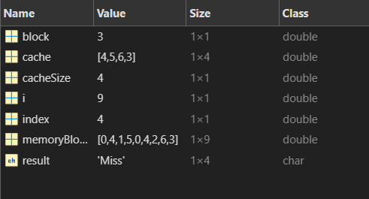

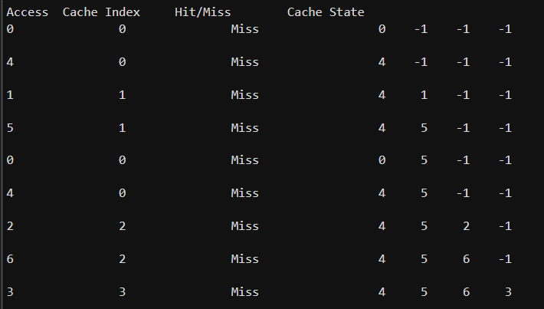

ADDITION QUESTION:

1. Explain how cache improves computer speed in real-world applications like gaming.

CODE:
clc; clear;
close all;

cacheSize = 4;
cache = -1 * ones(1, cacheSize);

memoryBlocks = [1 2 3 4 1 2 5 1 2 3 4 5];
hits = 0;
misses = 0;

fprintf('Block\tHit/Miss\tCache State\n');
for i = 1:length(memoryBlocks)
block = memoryBlocks(i);

if ismember(block, cache)
result = 'HIT';
hits = hits + 1;

else
result = 'MISS';
misses = misses + 1;
cache(1:end-1) = cache(2:end);
cache(end) = block;
end
fprintf('%d\t%s\t\t', block, result);
disp(cache);

end
fprintf('\nTotal Hits: %d\n', hits);
fprintf('Total Misses: %d\n', misses);

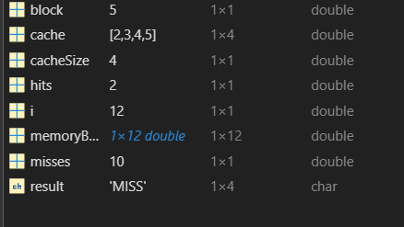

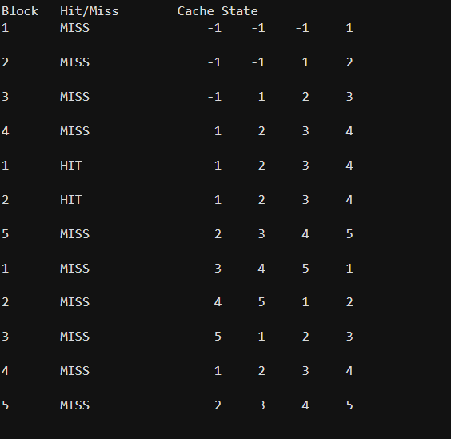

2. Assess how frequent cache misses could affect video streaming or online classes.

CODE:

clc; clear;
close all;

cacheSize = 3;
cache = -1 * ones(1, cacheSize);

dataStream = [1 2 3 4 1 2 5 1 2 3 4 5];
hits = 0;
misses = 0;

fprintf('Data\tHit/Miss\tCache State\n');
for i = 1:length(dataStream)
block = dataStream(i);

if ismember(block, cache)
result = 'HIT';
hits = hits + 1;
else
result = 'MISS';
misses = misses + 1;

cache(1:end-1) = cache(2:end);
cache(end) = block;

end
fprintf('%d\t%s\t\t', block, result);
disp(cache);

end
fprintf('\nTotal Cache Hits: %d\n', hits);
fprintf('Total Cache Misses: %d\n', misses);

missRate = (misses/length(dataStream))*100;
fprintf('Cache Miss Rate: %.2f%%\n', missRate);

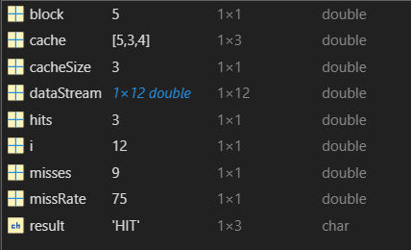

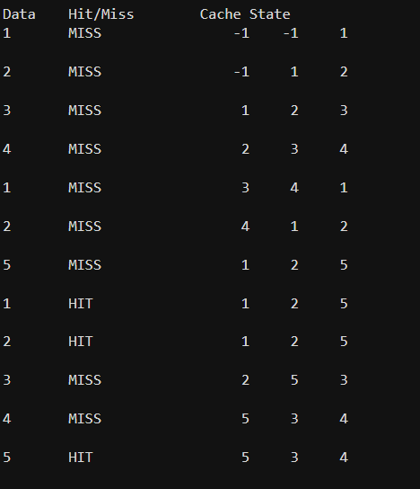

- Actual Resources Used

S. No. | Name of Resource | Broad Specifications |  | Data | Remarks  (If any)
 |  | Tool | Version
 | Laptop | Intel Core i5 Processor, 8GB RAM | MATLAB | R2023a | Used to run cache simulation
 | MATLAB Software | Programming and simulation environment | MATLAB | R2023a | Used to execute the script
 | Internet | Broadband connection | Chrome Browser | Latest | Used for reference
 | Operating System | Windows OS | Windows | Windows 11 | System environment

- Actual Procedure Followed
- The computer system was switched on and MATLAB software was opened.
- The provided MATLAB code for cache direct mapping simulation was typed in the script editor.
- The cache size and memory block access sequence were defined in the program.
- The direct mapping formula (block mod cache size) was applied in the code.
- The program was executed using the Run option in MATLAB.
- The output showing cache index, hit/miss, and cache state was observed in the command window.
- Observations and Dimensional Measurement

S. No. | Observations | Data | Remarks
1 | Cache Size | 4 blocks | Defined in program
2 | Memory Block Sequence | 0, 4, 1, 5, 0, 4, 2, 6, 3 | Used for simulation
3 | Cache Hits | 2 | When requested block already in cache
4 | Cache Misses | 7 | When block not found in cache

- Results/Observations

- The MATLAB program successfully simulated direct cache mapping technique.
- The output displayed the cache index, hit or miss status, and cache state for each memory access.
- It was observed that direct mapping is simple and fast but causes collisions when multiple blocks map to the same cache line.

- Interpretation of Results

The results show how cache memory improves system performance by reducing the time required to access frequently used data. When a requested memory block is already present in the cache, a cache hit occurs, resulting in faster data access. When the block is not present, a cache miss occurs and the block must be fetched from main memory. Direct mapping is efficient but may lead to conflicts when multiple memory blocks map to the same cache location.

- Conclusions

The practicum successfully demonstrated the working of direct cache mapping using MATLAB. The simulation helped in understanding how memory blocks are mapped to cache lines using a simple formula. It also showed the occurrence of cache hits and misses during memory access. From the experiment, it can be concluded that cache mapping techniques play an important role in improving the performance and efficiency of computer systems.

- Suggested Practicum Related Questions:

Note: Below are a few questions related to industry-specific higher-order thinking skills (HOT) that teachers must use to ensure students achieve the predetermined course outcomes.

- Explain how cache improves computer speed in real-world applications like gaming.
- Predict what happens if cache memory is too small when running multiple programs.
- Justify why industries use different mapping methods (direct, associative, set-associative).
- Assess how frequent cache misses could affect video streaming or online classes.
- Determine which mapping method is more efficient for multitasking systems and explain why.
- Examine what happens if two memory blocks map to the same cache line in direct mapping.
- Illustrate how programmers benefit when cache mapping reduces data access time.
- Evaluate why cache memory is more expensive than RAM yet still necessary in systems.
- Discuss how poor cache performance could slow down banking or airline booking systems.
- Propose how cache mapping techniques can influence the design of modern processors.

- References / Suggestions for further reading

- Cache Mapping Techniques - https://www.geeksforgeeks.org/computer-organization-architecture/cache-mapping-techniques/
- Cache Mapping and Types = https://youtu.be/hhLdy3J9oqg

- Suggested Assessment Scheme

The performance indicators given serve as a guideline for assessing the ‘process-related skills/LOs’ (marks to be awarded in real-time in the laboratory by the faculty member, as these cannot be measured after the practicum is over) and ‘product-related skills/LOs’

Note: The weightage for the process-related skills and product-related skills will change depending on the PrO, COs, and the competency related to the concerned course.

Performance Indicators |  | Maximum Marks | Marks Obtained
Process-related Skills: 18 Marks - 60%
1 | Follow industry standards | 3
2 | Function effectively in teams | 2
3 | Function responsibly in leadership | 3
4 | Implement cache mapping techniques and simulate direct memory access operations | 10
Product-related Skills: 12 Marks - 40%
5 | Uses correct commands or syntax in Tool | 3
6 | Results | 3
7 | Interpretation of Results | 3
8 | Conclusion | 3
Total |  | 30

To be filled by Student:

S.No. | Name of the Student | Register No.
1 | Neavis Rishva. J | URK25CS1236

To be filled by the Faculty Member:
Marks Obtained |  |  | Name and Designation of the Faculty Member | Date of Evaluation
Process-Related Skills  (18) | Product-Related Skills (12) | Total  (30)
*******

